public class Main{

public static void main(String []args){

System.out.println("hii java");

}

}

public class Student1

{

int id;

String name;

public static void main(String args[])

{

Student1 s1=new Student1();

System.out.println(s1.name);

}

}

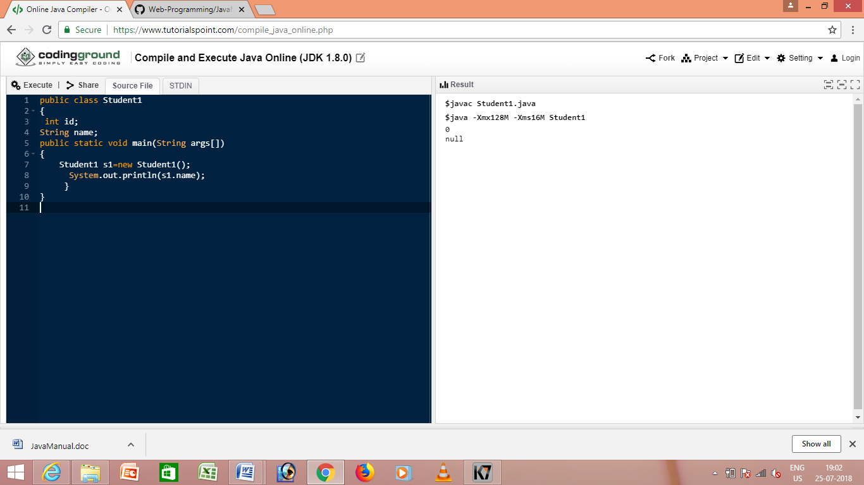

public class Student2{

int rollno;

String name;

void insertRecord(int r, String n){ //method

rollno=r;

name=n;

}

void displayInformation(){System.out.println(rollno+" "+name);}

public static void main(String args[])

{

Student2 s1=new Student2();

Student2 s2=new Student2();

s1.insertRecord(111,"Karan");

s2.insertRecord(222,"Aryan");

s1.displayInformation();

s2.displayInformation();

}

}

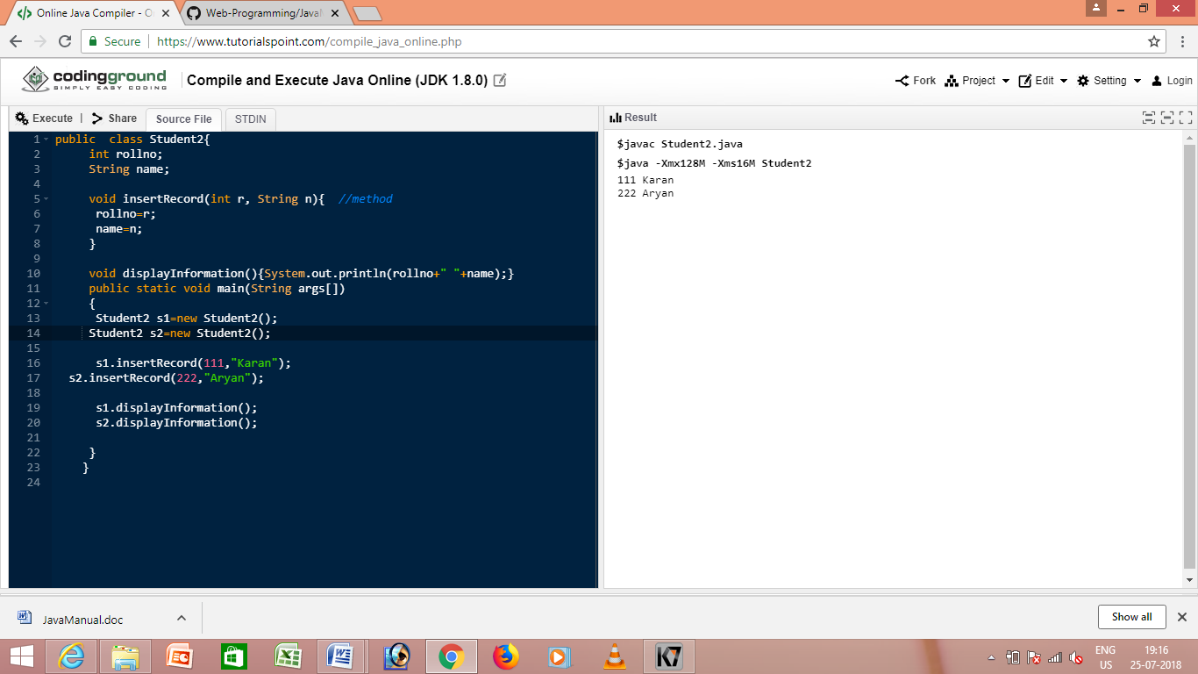

public class Rectangle{

int length;

int width;

void insert(int l,int w){

length=l;

width=w;

}

void calculateArea(){System.out.println(length\*width);}

public static void main(String args[]){

Rectangle r1=new Rectangle();

Rectangle r2=new Rectangle();

r1.insert(11,5);

r2.insert(3,15);

r1.calculateArea();

r2.calculateArea();

}

}

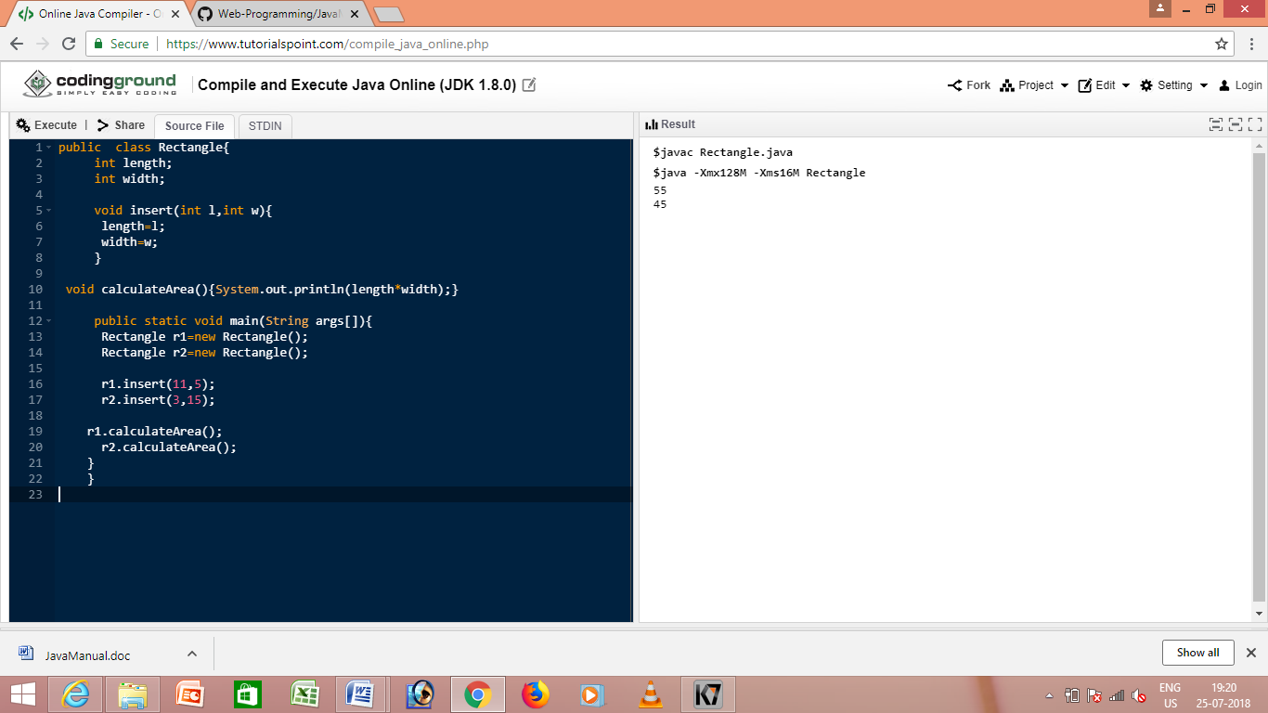

public class Calculation{

void fact(int n){

int fact=1;

for(int i=1;i<=n;i++){

fact=fact\*i;

}

System.out.println("factorial is "+fact);

}

public static void main(String args[]){

new Calculation().fact(5);//calling method with annonymous object

}

}

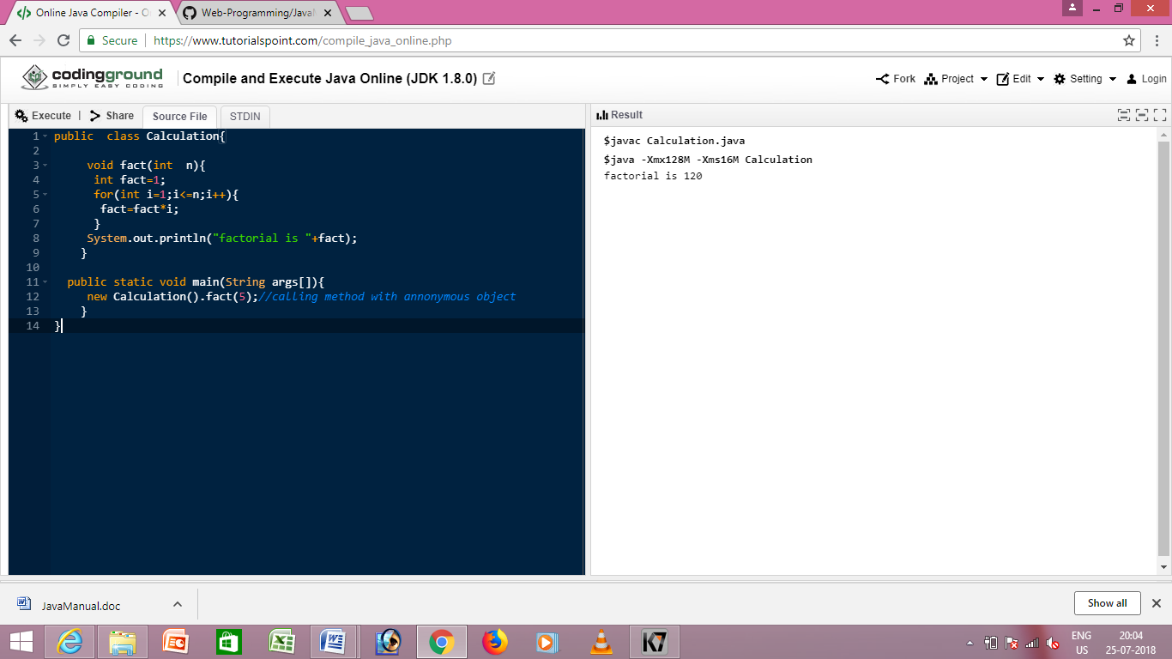

public class Rectangle{

int length;

int width;

void insert(int l,int w){

length=l;

width=w;

}

void calculateArea(){System.out.println(length\*width);}

public static void main(String args[]){

Rectangle r1=new Rectangle(),r2=new Rectangle();//creating two objects

r1.insert(11,5);

r2.insert(3,15);

r1.calculateArea();

r2.calculateArea();

}

}

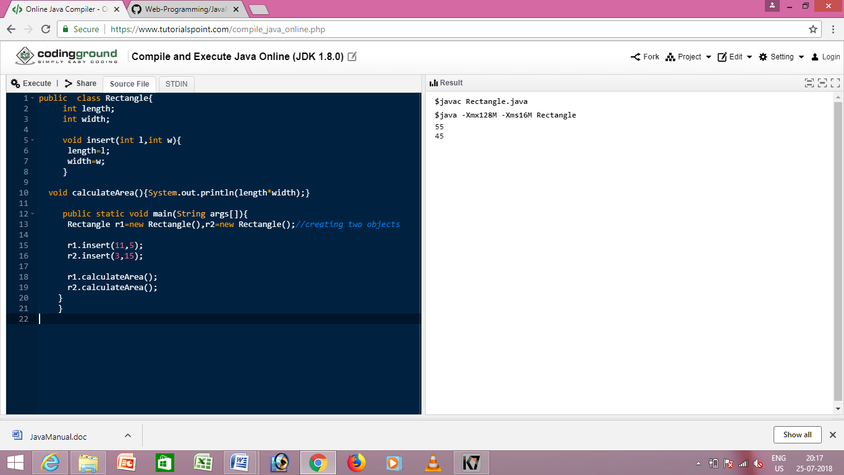

public class Calculation{

void sum(int a,int b){System.out.println(a+b);}

void sum(int a,int b,int c){System.out.println(a+b+c);}

public static void main(String args[]){

Calculation obj=new Calculation();

obj.sum(10,10,10);

obj.sum(20,20);

}

}

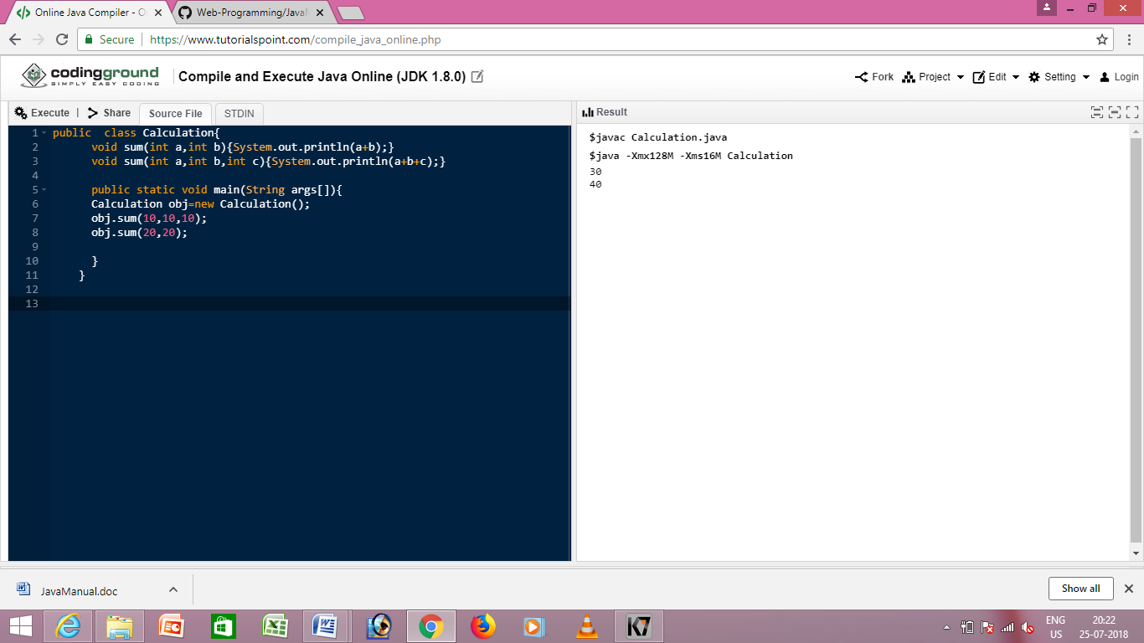

public class Calculation2{

void sum(int a,int b){System.out.println(a+b);}

void sum(double a,double b){System.out.println(a+b);}

public static void main(String args[]){

Calculation2 obj=new Calculation2();

obj.sum(10.5,10.5);

obj.sum(20,20);

}

}

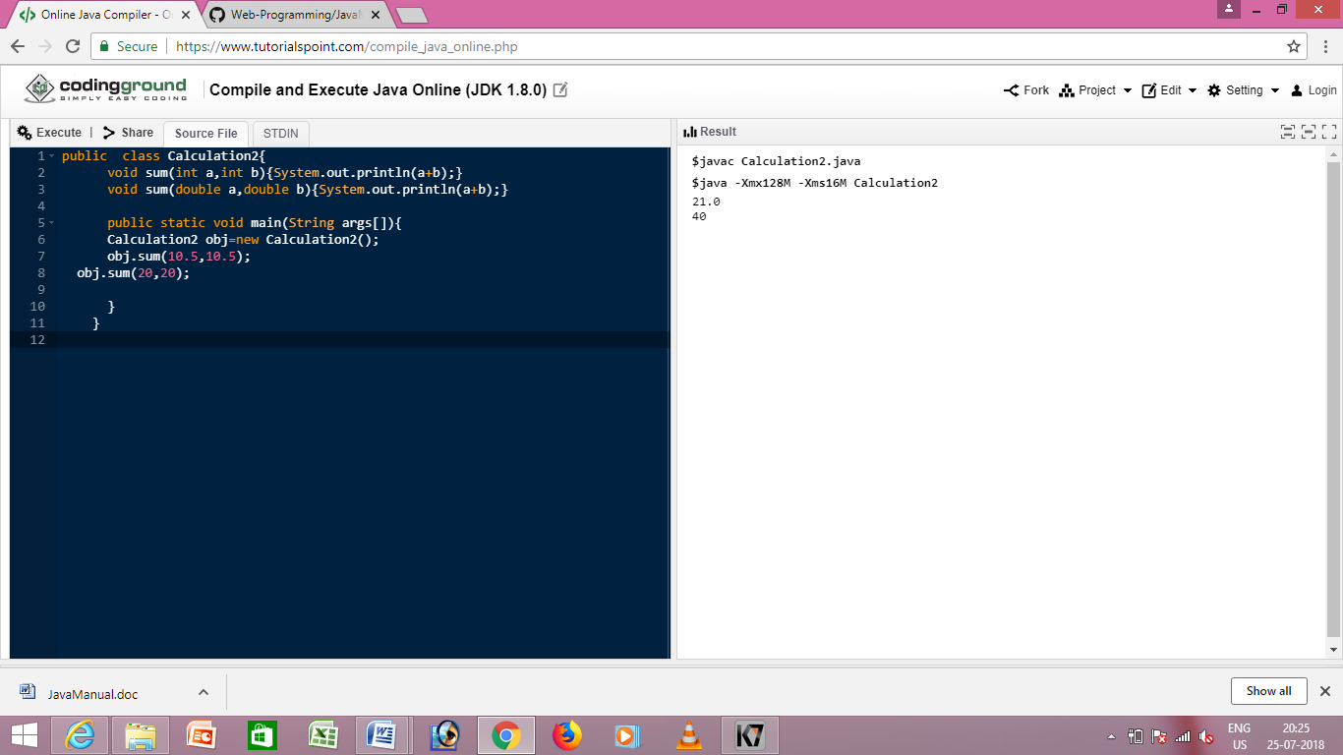

public class Overloading1{

public static void main(int a){

System.out.println(a);

}

public static void main(String args[]){

System.out.println("main() method invoked");

main(10);

}

}

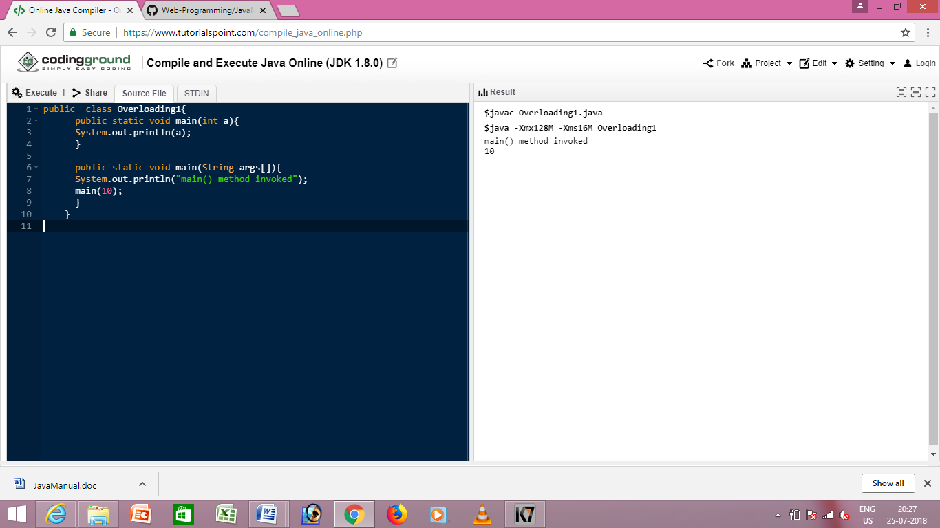

public class OverloadingCalculation1{

void sum(int a,long b){System.out.println(a+b);}

void sum(int a,int b,int c){System.out.println(a+b+c);}

public static void main(String args[]){

OverloadingCalculation1 obj=new OverloadingCalculation1();

obj.sum(20,20);//now second int literal will be promoted to long

obj.sum(20,20,20);

}

}

